Oracle SQL Developer

Software Installation Guide

## Installation Requirements

* Internet Access
  + UCONN-SECURE, Not UCONN-GUEST
  + Or wired (Ethernet connection) while on a UConn Campus
* **Access from off campus will require a** [**UConn VPN session**](https://remoteaccess.uconn.edu/vpn-overview/connect-via-vpn-client-2/)**, or use** [**OPIM Virtual Desktop (OVD)**](https://confluence.uconn.edu/display/BUSNIT/OPIM+Virtual+Desktop)
* Installation requires elevated or admin access. (Ability to write to C:\)

**Resources:**

<http://www.oracle.com/technetwork/developer-tools/sql-developer/downloads/index.html>

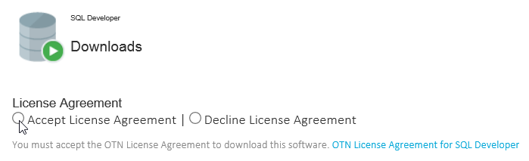

Click the radio button to “Accept the License Agreement”.

Review the list of SQL Developer installers and click on the download link next to the appropriate installer for your Operating System.

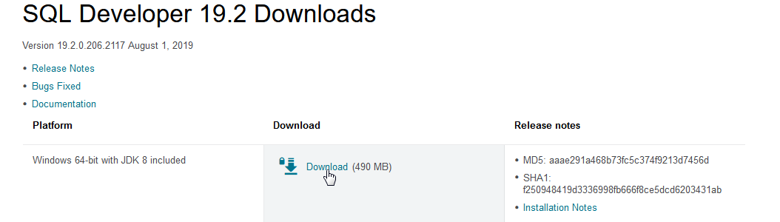

Click the download link next to Windows 64-bit with JDK 8 included.

If you are unsure if you have 32 or 64 bit Windows, choose the ‘Windows 32/64-bit’ option. Please install the latest available version of SQL Developer. These instructions will guide you through the process regardless of the version number.

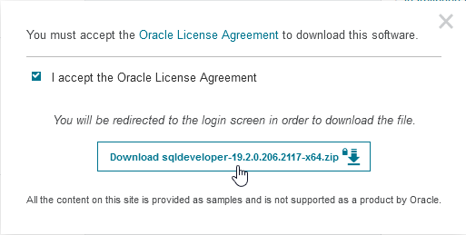

Place select “I accept the Oracle License Agreement.”  
Click on Download sqldeveloper-###...zip

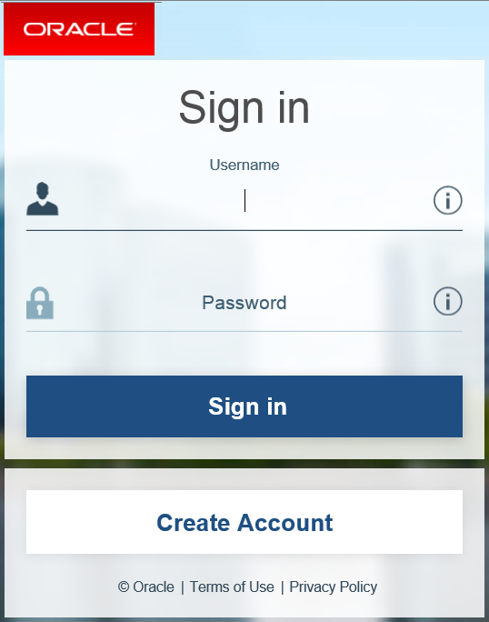

Log in or create an Oracle account if you do not yet have one. After logging in the file will begin to download automatically.

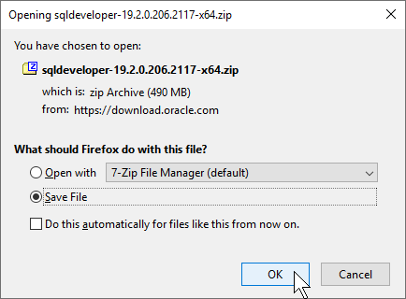

Click the option to Save File.

Click OK to download the file.

Navigate to your Downloads folder.

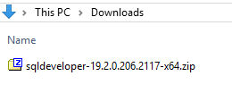

The downloaded file is a compressed archive, a zip file.

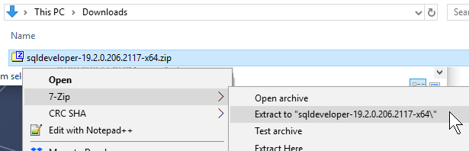

Right click on the file and select the option to “Extract to” the subfolder that contains the name of the archive.

NOTE: The version you download may be different from the one in the picture above.

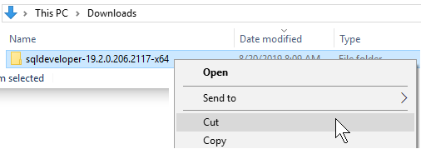

Right click on the new folder containing the uncompressed files. Example, “sqldeveloper-18.2.0.183.1748-x64” select Cut.

Paste the folder in C:\Program Files\. Open the folder and subfolder if present to find sqldeveloper.exe.



Click on the sqldeveloper.exe file once to select it. Then right click on the file to open the context menu. Select Send to> Desktop (create shortcut).

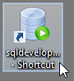

Use that newly create desktop shortcut to open Oracle sqldevopler.

The Oracle SQL Developer setup is complete.

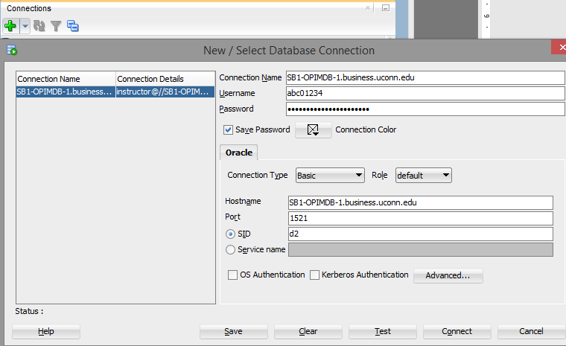

Click the green + icon under connections.

In the Connection name field, enter SB1-OPIMDB-1.business.uconn.edu.

In the Username field, enter your NetID.

The Password will be provided by your professor.

Select the option to Save Password.

In the Hostname field, enter SB1-OPIMDB-1.business.uconn.edu.

In the port field, enter 1521.

Select SID enter D2 in the SID field.

Click Save to preserve the settings for future connections to the database server.

**NOTE:**

**If you require a password reset, please contact your professor. Professors have the ability to reset passwords. It is especially important to verify that your password has not expired well in advance of important assignments, exams and when prompted to change it by the server.**

## Troubleshooting:

The most common connectivity issues are caused by clients or laptop configuration issues. Connectivity to SB1-OPIMDB-1.business.uconn.edu requires TCPIP port 1521 be open.

Make sure you are connected to UCONN-SECURE, not UCONN-GUEST, or are connected by Ethernet while on campus.

If you are off campus make sure you are using [UConn VPN](https://remoteaccess.uconn.edu/vpn-overview/connect-via-vpn-client-2/) , or use [OPIM Virtual Desktop (OVD)](https://confluence.uconn.edu/display/BUSNIT/OPIM+Virtual+Desktop)

If you are using Norton Internet Security Suite or a similar Internet Security Suite, please make sure you have created a firewall exception for TCP/IP port 1521.

If you are still unable to connect please send an email to [help@business.uconn.edu](mailto:help@business.uconn.edu). Please include your NetID and a screen capture or thorough explanation of any errors you may be receiving.